**特点**

no always-on server

arbitrary end systems directly communicate

peers are intermittently connected and change IP address

**分发时间**

client-server

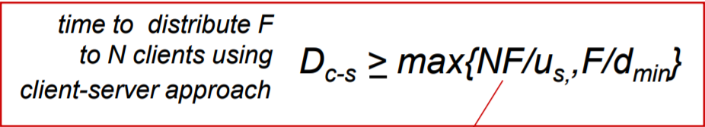

p2p

